Adding a new Product Group
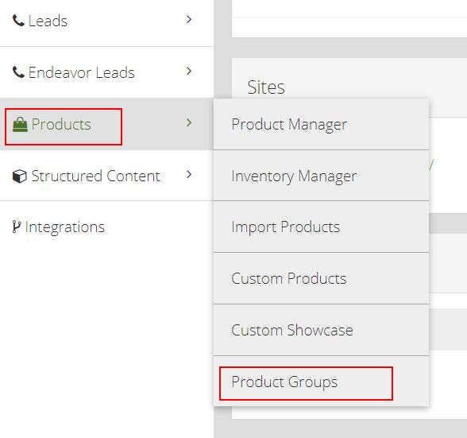
1. On the left hand navigation of CMS navigate to Products -> Product Groups
2. This is where you will create new Product Groups
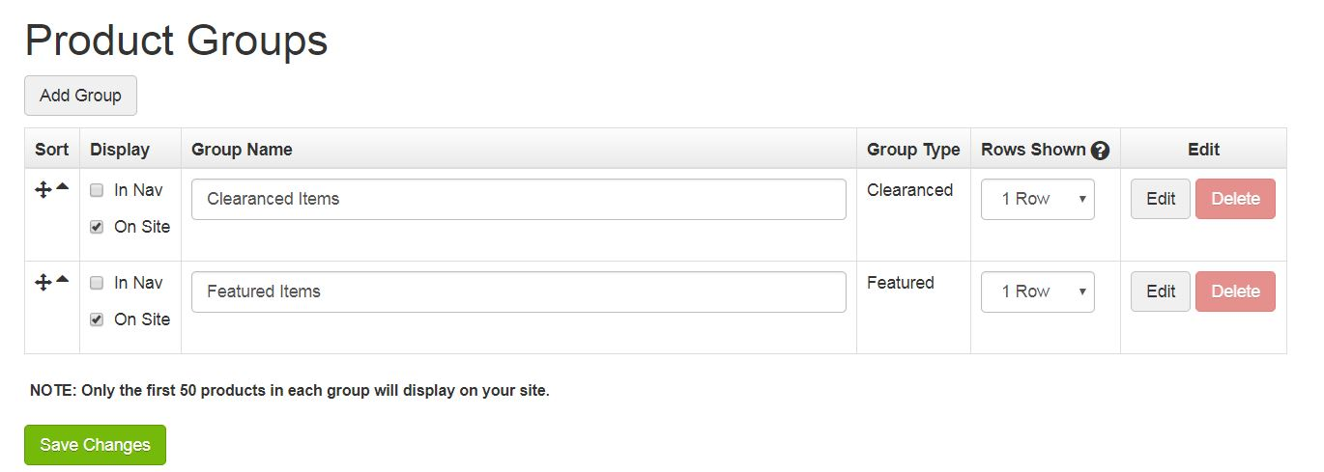
3. Use Add Group Button at the top of the page and rename newly created group (Custom Product Group 1)
-What you name this is what will show up as the Product Group Header on the live site, as well as in the component drop down (instructions later).
-Make sure the "On Site" box is checked or it will not show on the site.
-Save Changes
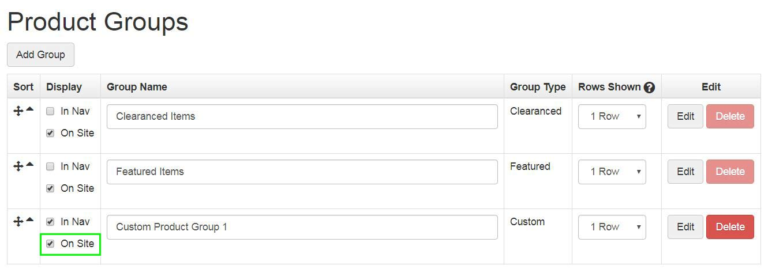

Adding Products to New Product Group
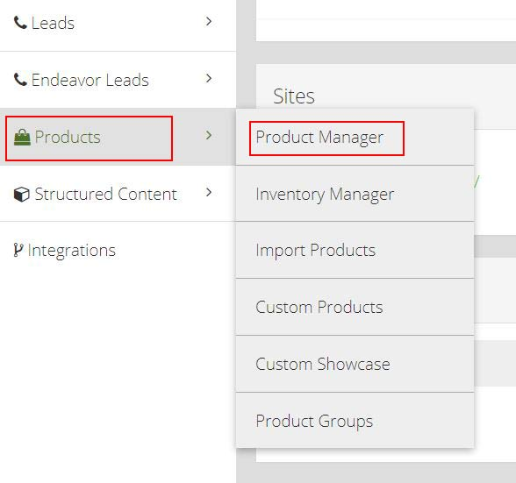
1. On the left side navigation Products -> Product Manager
- *Only showcase items will show on Responsive sites
- *Ecomm products will not display
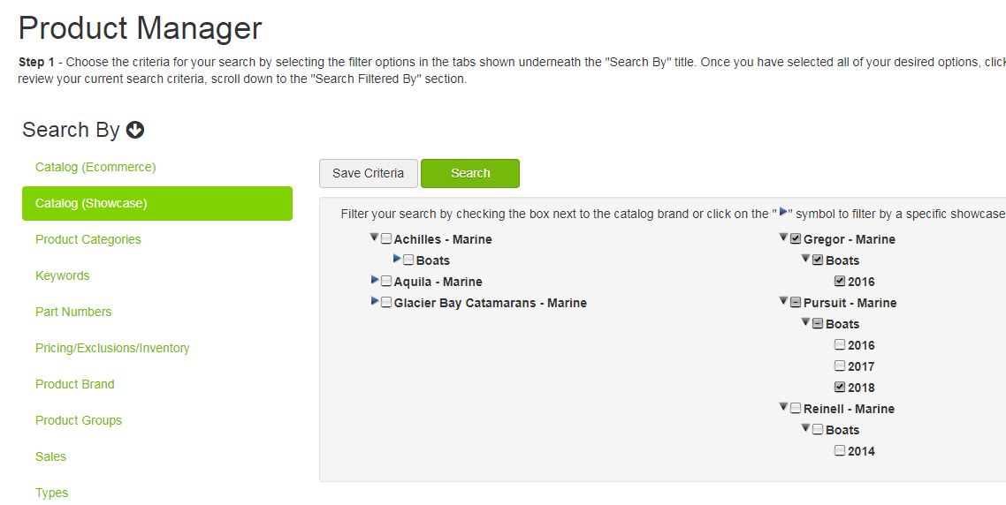
2. Using the Product Manager page, perform a search for the items you wish to use in your Product Group
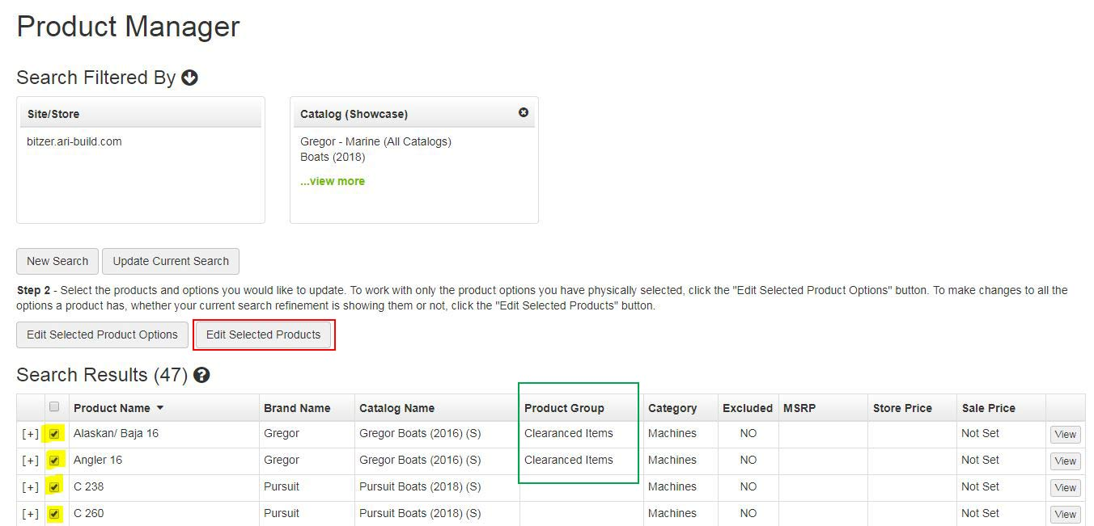
Note:
- If the item says YES in the Excluded column, it will not show on the site. It will need to be switched to No
3. Use check boxes to select multiple units at a time (up to 50)
- "Checked" boxes are highlighted for example
- The column outlined in green will tell you if these items currently reside in a product group
4. Use Edit Selected Products button (outlined in red above) when you have selected your units
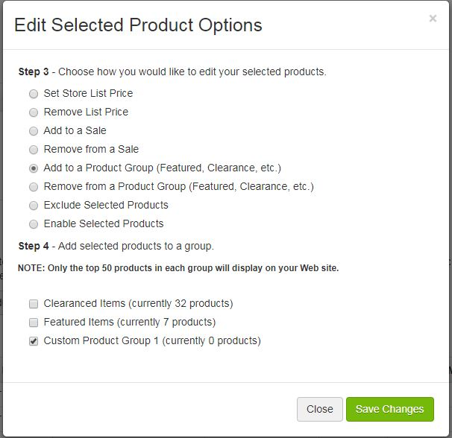
5. Select Add to a Product Group
6. Select the Product Group you'd like your items to be placed in
7. Save Changes

Adding Inventory to New Product Group
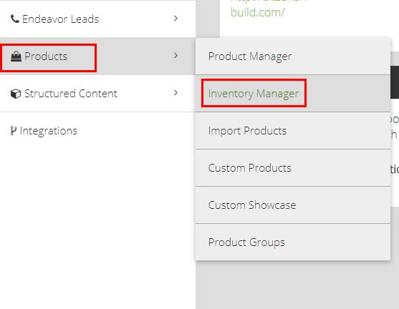
1. On the left side navigation Products -> Inventory Manager
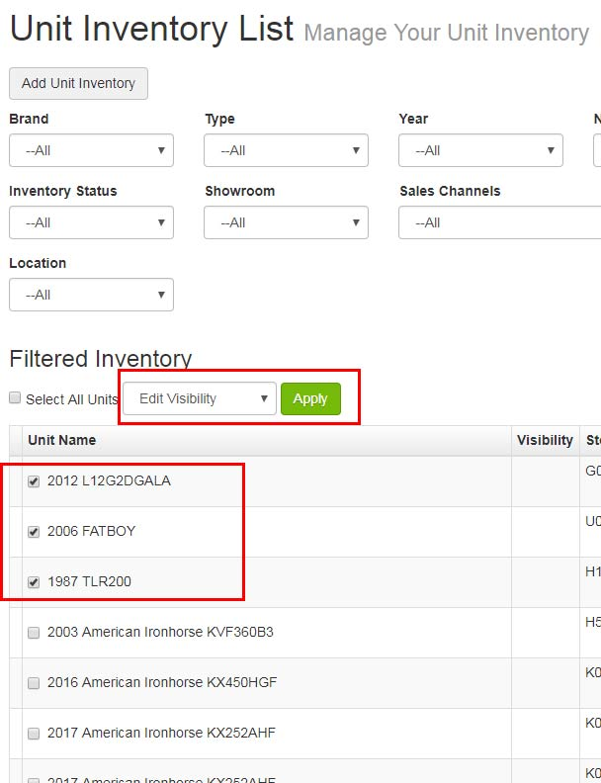
2. Using the Unit Inventory page, select the items you'd like for your product group
3. Use the drop down and select Edit Visibility and Apply
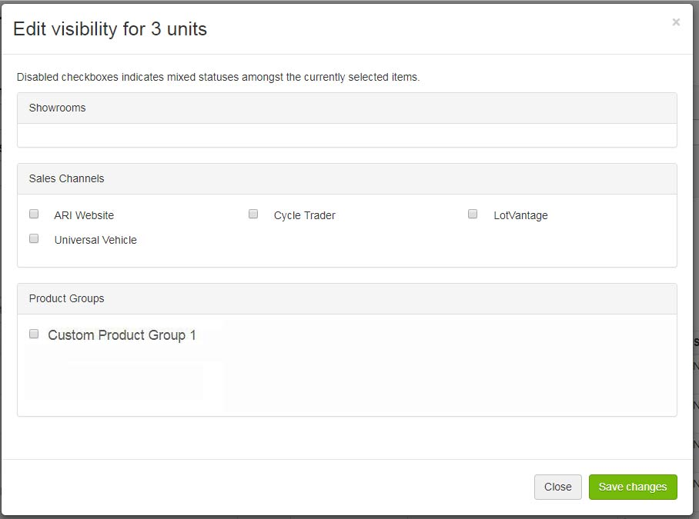
4. Select new Product Group check box
5. Save Changes
6. Publish Changes

Adding Inventory to New Product Group
1. On the left side navigation Products -> Inventory Manager
2. Using the Unit Inventory page, select the items you'd like for your product group
3. Use the drop down and select Edit Visibility and Apply
4. Select new Product Group check box
5. Save Changes
6. Publish Changes

Adding an Item Groups & Showrooms Component
After creating the new Product Group, it must be added to it's own Item Groups & Showrooms Component.
(You will have to do with for EVERY product group)
1. Navigate to Components from the homepage of CMS or dashboard
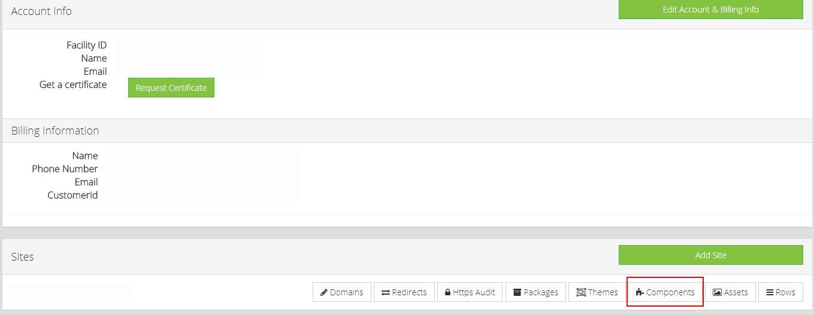
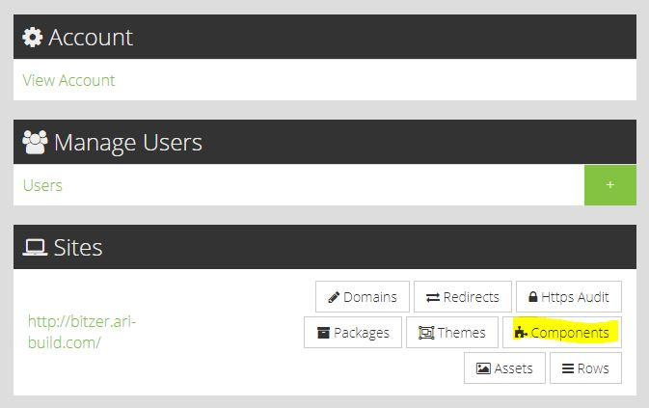
2. If there is currently an Item Groups & Showrooms Component active, use the "Add Another" link to... you guessed it... add another!
- If there isn't an active component, this may be in the Inactive Components tab and would need to be turned on
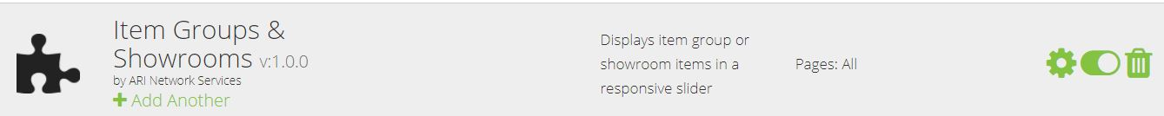
3. Name the new Component using the same name you used for the Product Group (This will make it easier to distinguish on the main Component page)
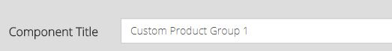
4. Add page rules to the template of the Component and the section for your component to live in
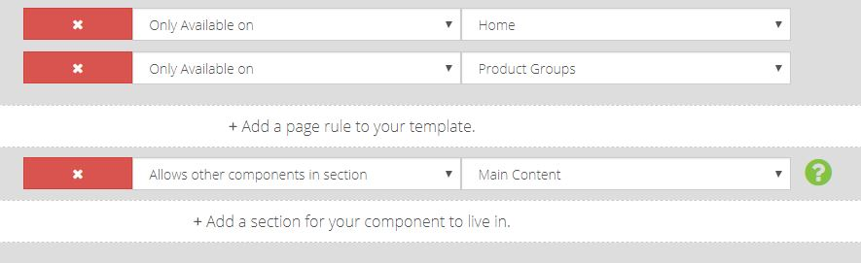
- Typically you'd have these set to "Only Available on" Home and Product Groups
- You want to "Allow other components in section" and place it in the "Main Content"
5. Choose your new product group from the Item Groups drop down
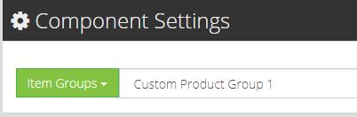
6. Save Settings

Adding the Item Group & Showroom Component to Layout Manager
  - From CMS Dashboard navigate to Layouts

  - Choose Layout
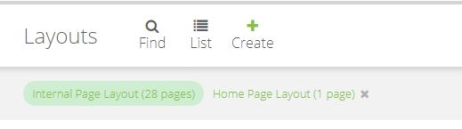

  - Add new row to section
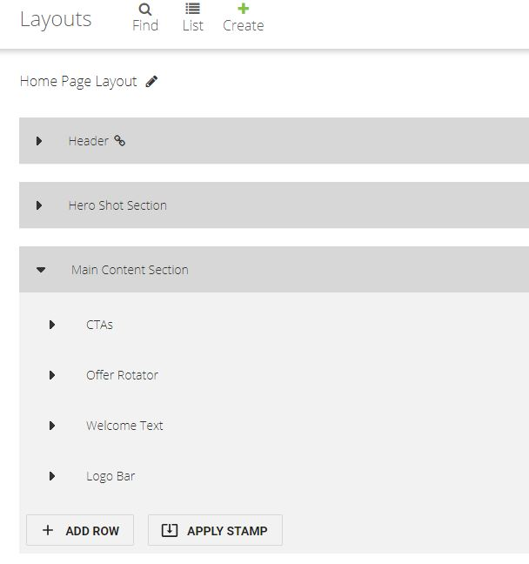
  - Name Row using Edit icon
  - Select a preset (Typically 1 column)

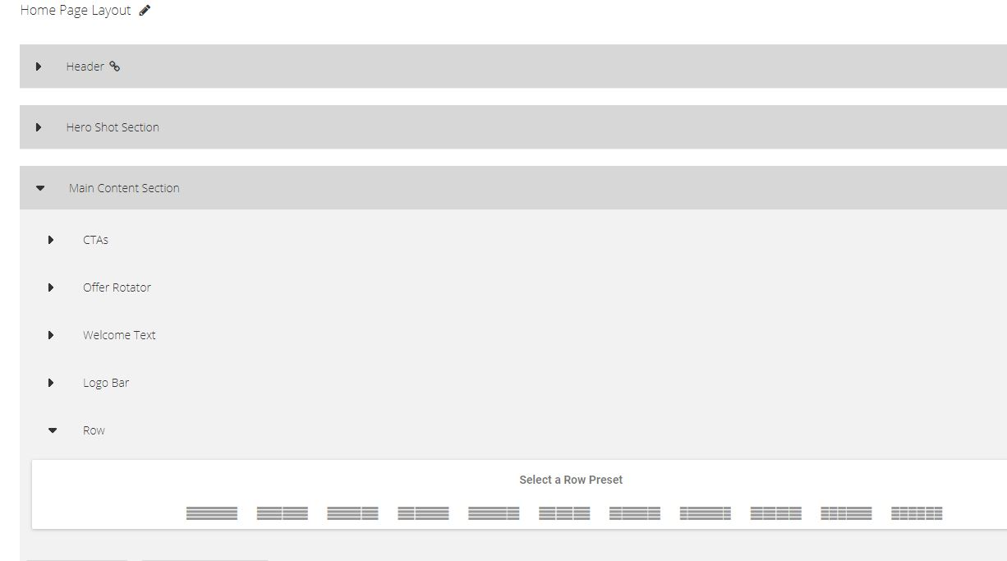

  - Add Element to column
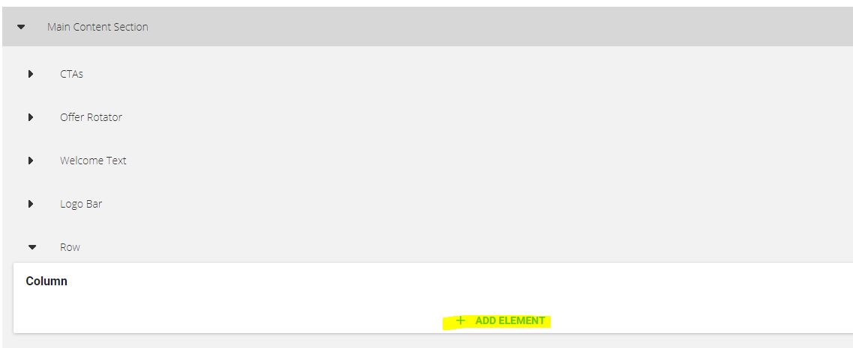

  - Expand Item Groups & Showrooms

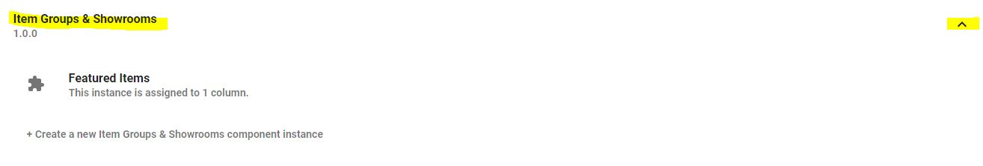

  - Choose desired Product group
  - Publish changes
  - Remember to perform the same steps for ANY layouts you wish to show product groups on
*If you want them to show on the internal page for Product groups it needs to be added to the Internal Page Layout

